WareHouse Management System Using LORA-ESP32

Sender Door LORA Devices :

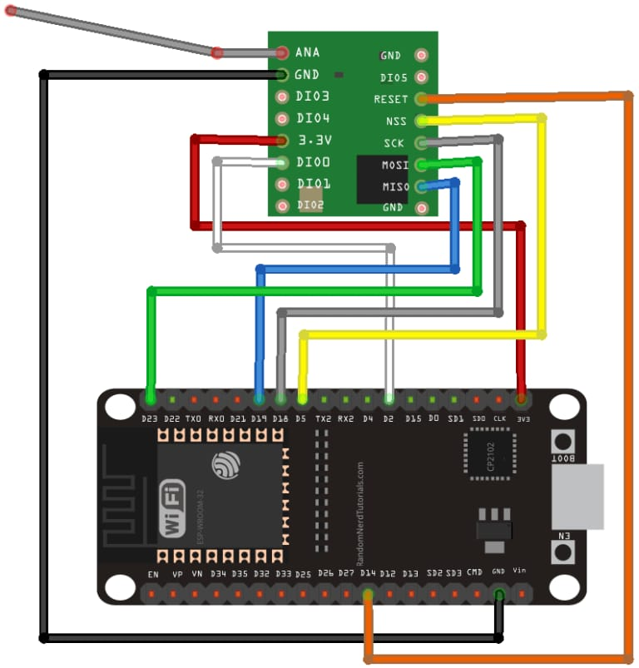
RFM95 Module connected with esp32 is use. This device will send
the “>DOOR_Num<” to the Receiver LORA Module every 10 seconds

Check Properly the Door Number and its respective gps location in csv file and fix it there.
Improper configuration leads to wrong Information on WebMap

Arduino Code :

#include <SPI.h>
#include <LoRa.h>

// Define the pins used by the LoRa transceiver module
#define ss 5 // Slave Select (SS) pin
#define rst 14 // Reset (RST) pin
#define dio0 2 // Digital Input/Output 0 (DIO0) pin
int counter = 0;

void setup() {
// Initialize Serial Monitor for debugging
Serial.begin(115200);
while (!Serial); // Wait for Serial Monitor to open
Serial.println("LoRa Sender");

// Setup LoRa transceiver module using specified pins for SS, RST, and DIO0
LoRa.setPins(ss, rst, dio0);
// Initialize the LoRa module with a specified frequency (915 MHz in this case)
// Keep trying until LoRa.begin() returns true, indicating successful initialization
while (!LoRa.begin(915E6)) {
Serial.println("."); // Display dots while waiting for initialization
delay(500);
}
// Change the sync word to 0xF3 to match the receiver's sync word
// This ensures that only LoRa messages with the same sync word are received
LoRa.setSyncWord(0xF3);
Serial.println("LoRa Initializing OK!");
}

void loop() {
// Display the packet number being sent in the Serial Monitor
Serial.print("Sending packet: ");
Serial.println(counter);

// Send a LoRa packet to the receiver
LoRa.beginPacket();
LoRa.print(">DOOR_3<"); // Transmit a message ('>DOOR_3<') to the receiver
LoRa.endPacket();

// Increment the counter for the next packet
counter++;

// Wait for a delay of 10 seconds before sending the next packet
delay(10000);
}

Receiver Door LORA Device :

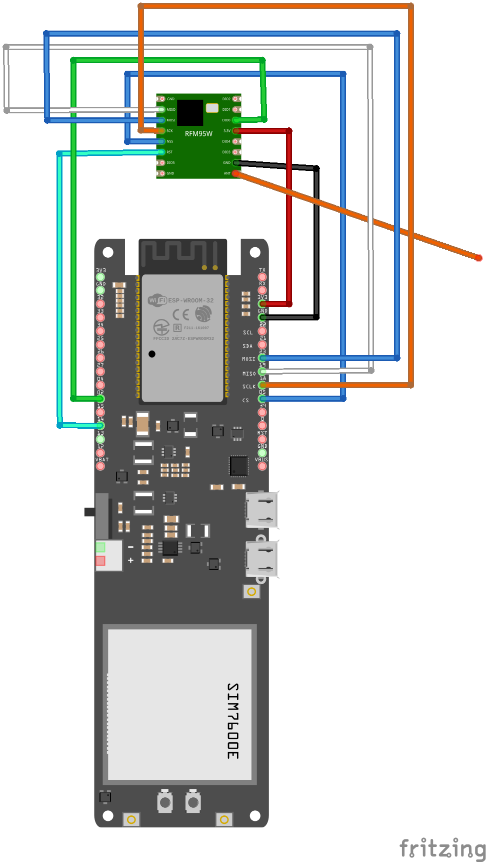

Arduino Code :
#include <SPI.h>
#include <LoRa.h>

// Define the pins used by the LoRa transceiver module
#define ss 5 // Slave Select pin for LoRa
#define rst 14 // Reset pin for LoRa
#define dio0 2 // Digital IO pin for LoRa interrupt

// Define serial ports for communication
#define SerialMon Serial // Serial monitor
#define SerialAT Serial1 // Serial communication with GSM modem

// GSM settings
char apn[] = "mnet"; // Access Point Name for GSM
char user[] = ""; // Username for GSM, if needed
char pass[] = ""; // Password for GSM, if needed
#define GSM_PIN "" // PIN for SIM card, if required
#define TINY_GSM_MODEM_SIM7600 // GSM modem type
#define TINY_GSM_RX_BUFFER 1024 // Set RX buffer size for GSM communication

#include <TinyGsmClient.h> // Library for GSM communication
#include "utilities.h" // Utility functions

// Create an instance of the TinyGsmClient for GSM communication
TinyGsm modem(SerialAT);

// Define LED pins
#define red 12 // Red LED pin
#define blue 15 // Blue LED pin
#define green 13 // Green LED pin (Start LED)

// Server and path details for HTTP request
const char server[] = "ernd.tech"; // Server address
const char path[] = "/test/csvmap.php?doorNumbers="; // Path including query parameters

// GSM client for HTTP
TinyGsmClient client(modem);

unsigned long startTime;
unsigned long duration = 60000; // 1 minute in milliseconds
String receivedDoors = "";

void setup() {
// Initialize Serial Monitor for debugging
Serial.begin(115200);
while (!Serial); // Wait until Serial Monitor is ready
Serial.println("LoRa Receiver");

// Setup LoRa transceiver module
LoRa.setPins(ss, rst, dio0);

// Start AT mode for GSM communication
SerialAT.begin(115200, SERIAL_8N1, MODEM_RX, MODEM_TX);
startModem(); // Initialize the GSM modem

// Start LoRa module on the specified frequency
while (!LoRa.begin(915E6)) {
Serial.println(".");
delay(500);
}
LoRa.setSyncWord(0xF3); // Set LoRa sync word
Serial.println("LoRa Initializing OK!");

// Connect to GPRS for GSM communication
if (!modem.gprsConnect(apn, user, pass)) {
Serial.println("Failed to connect to GPRS");
return;
}

Serial.println("Connected to GPRS");

blinkLED(blue); // Blink the blue LED to indicate connection
blinkLED(blue);
blinkLED(blue);

startTime = millis(); // Initialize start time
}

void loop() {
// Check for incoming LoRa packets for 1 minute
while (millis() - startTime < duration) {
if (LoRa.parsePacket()) {
String packet = "";
while (LoRa.available()) {
packet += (char)LoRa.read();
}
// Extract door number from the packet and add it to the list
int startPos = packet.indexOf(">") + 6;
int endPos = packet.indexOf("<");
String doorNum = packet.substring(startPos, endPos);
receivedDoors += doorNum + ",";
}
}

// Perform HTTP POST request with collected door numbers
if (receivedDoors.length() > 0) {
receivedDoors.remove(receivedDoors.length() - 1); // Remove last comma
postReq(receivedDoors); // Send the collected data
}

// Reset variables for the next iteration
receivedDoors = "";
startTime = millis();
}

// Function to initialize the GSM modem
void startModem() {
// Power on and initialize GSM modem
pinMode(MODEM_PWRKEY, OUTPUT);
digitalWrite(MODEM_PWRKEY, HIGH);
delay(300);
digitalWrite(MODEM_PWRKEY, LOW);

pinMode(MODEM_FLIGHT, OUTPUT);
digitalWrite(MODEM_FLIGHT, HIGH);

// Attempt to start the modem
for (int i = 0; i < 3; ++i) {
while (!modem.testAT(5000)) {
Serial.println("Try to start modem...");
pinMode(MODEM_PWRKEY, OUTPUT);
digitalWrite(MODEM_PWRKEY, HIGH);
delay(300);
digitalWrite(MODEM_PWRKEY, LOW);
}
}

// Restart the modem if needed
SerialMon.println("Initializing modem...");
if (!modem.restart()) {
Serial.println("Failed to restart modem, attempting to continue without restarting");
}
}

// Function to perform an HTTP POST request with collected door numbers
void postReq(String doors) {
Serial.print("doorNumData:");
Serial.println(doors);

// Connect to the server
if (client.connect(server, 80)) {
// Send HTTP POST request
client.println("POST " + String(path) + " HTTP/1.1");
client.println("Host: " + String(server));
client.println("Connection: close");
client.println("Cache-Control: no-cache");
client.println();

// Send the collected data
client.println(doors);

// Read and print the server response
while (client.connected()) {
if (client.available()) {
char c = client.read();
Serial.print(c);
}
}
client.stop(); // Close the connection
} else {
Serial.println("connection failed");
}
}

// Function to blink an LED
void blinkLED(int pin) {
digitalWrite(pin, LOW);
delay(1500);
digitalWrite(pin, HIGH);
delay(1500);
}

Web Map :
Note: Place the web Files in same Folder and Paste the content as it is…

- CSV File
Door Num, GPS Lang, GPS Lati, Status

door.csv
DOOR1,34.052417,-118.365528,0
DOOR2,34.052171,-118.365892,0
DOOR3,34.052237,-118.365821,0
DOOR4,34.052335,-118.365809,0
DOOR5,34.052362,-118.365796,0
DOOR6,34.052396,-118.365786,0

- csvmap.php
<?php
// Avoid caching for the file
header('Cache-Control: no-store, no-cache, max-age=0, must-revalidate, proxy-revalidate');
header('Cache-Control: post-check=0, pre-check=0', false);
header('Pragma: no-cache');

// Read the content of the 'door.csv' file into an array ($file), each line as an element
$file = file('door.csv');

// Extract the door numbers from the URL parameter and convert it to an array
$doorNumbers = explode(",", $_GET['doorNumbers']);

// Loop through each line in the CSV file
foreach ($file as $index => $line) {
$doorDetails = explode(',', $line); // Split the line into an array by comma
$doorNumber = intval(trim($doorDetails[0], 'DOOR')); // Extract the door number and convert it to an integer

// Check if the door number is in the list to be updated
if (in_array($doorNumber, $doorNumbers)) {
$doorDetails[3] = '1'; // Modify the status to 1
} else {
$doorDetails[3] = '0'; // Set status to 0 for doors not in the list
}
$file[$index] = implode(',', $doorDetails). "\n"; // Update the line in the file
}

// Save the modified data back to the file
file_put_contents('door.csv', implode('', $file));

echo 'CSV file updated successfully!';
?>

- Map7.html
<!DOCTYPE html>
<html>
<head>
<title>OpenStreetMap with Markers from CSV</title>
<!-- Include Leaflet CSS and JavaScript -->
<link rel="stylesheet" href="https://unpkg.com/leaflet@1.7.1/dist/leaflet.css" />
<script src="https://unpkg.com/leaflet@1.7.1/dist/leaflet.js"></script>
<style>
/* Set the size of the map */
#map {
height: 1500px;
width: 100%;
}
</style>
</head>
<body>
<!-- The div element for the map -->
<div id="map"></div>

<script>
var map = L.map('map').setView([34.052396, -118.365786], 17); // Create a Leaflet map centered at specific coordinates

var markers = {}; // To store markers

// Add OpenStreetMap tile layer to the map
L.tileLayer('https://{s}.tile.openstreetmap.org/{z}/{x}/{y}.png', {
attribution: 'Map data &copy; <a href="https://www.openstreetmap.org/">OpenStreetMap</a> contributors',
maxZoom: 23
}).addTo(map);

// Fetch data from the PHP script that serves the CSV file
fetch('csvmap.php'); // Replace 'csvmap.php' with your PHP script URL

function fetchAndUpdateMarkers() {
// Fetch the CSV file with a timestamp to avoid caching
fetch('door.csv?' + new Date().getTime())
.then(response => response.text())
.then(data => {
var lines = data.split('\n'); // Split the CSV data into lines

lines.forEach(line => {
var parts = line.split(',');
var doorName = parts[0].trim(); // Extract door name
var coordinates = parts.slice(1).join(',').trim().replace(/[\[\]"']/g, ''); // Extract coordinates and status
var [latitude, longitude, status] = coordinates.split(',').map(coord => parseFloat(coord.trim()));

// Check the status to decide whether to show or remove the marker
if (status === 1) {
if (markers[doorName]) {
markers[doorName].setLatLng([latitude, longitude]); // Update marker position if exists
} else {
var marker = L.marker([latitude, longitude]).addTo(map); // Create a new marker if not exists
markers[doorName] = marker; // Store marker reference
marker.on('click', function() {
// Open Google Maps with marker's location on click
var url = 'https://maps.google.com/?q=' + this.getLatLng().lat + ',' + this.getLatLng().lng;
window.open(url, '_blank');
});
}
} else {
// Remove marker if status is not '1'
if (markers[doorName]) {
map.removeLayer(markers[doorName]);
delete markers[doorName];
}
}
});
})
.catch(error => {
console.error('Error fetching the CSV file:', error);
});
}

// Initially fetch and update markers
fetchAndUpdateMarkers();

// Update markers every 5 seconds
setInterval(fetchAndUpdateMarkers, 5000);
</script>
</body>
</html>

WebApp Working:

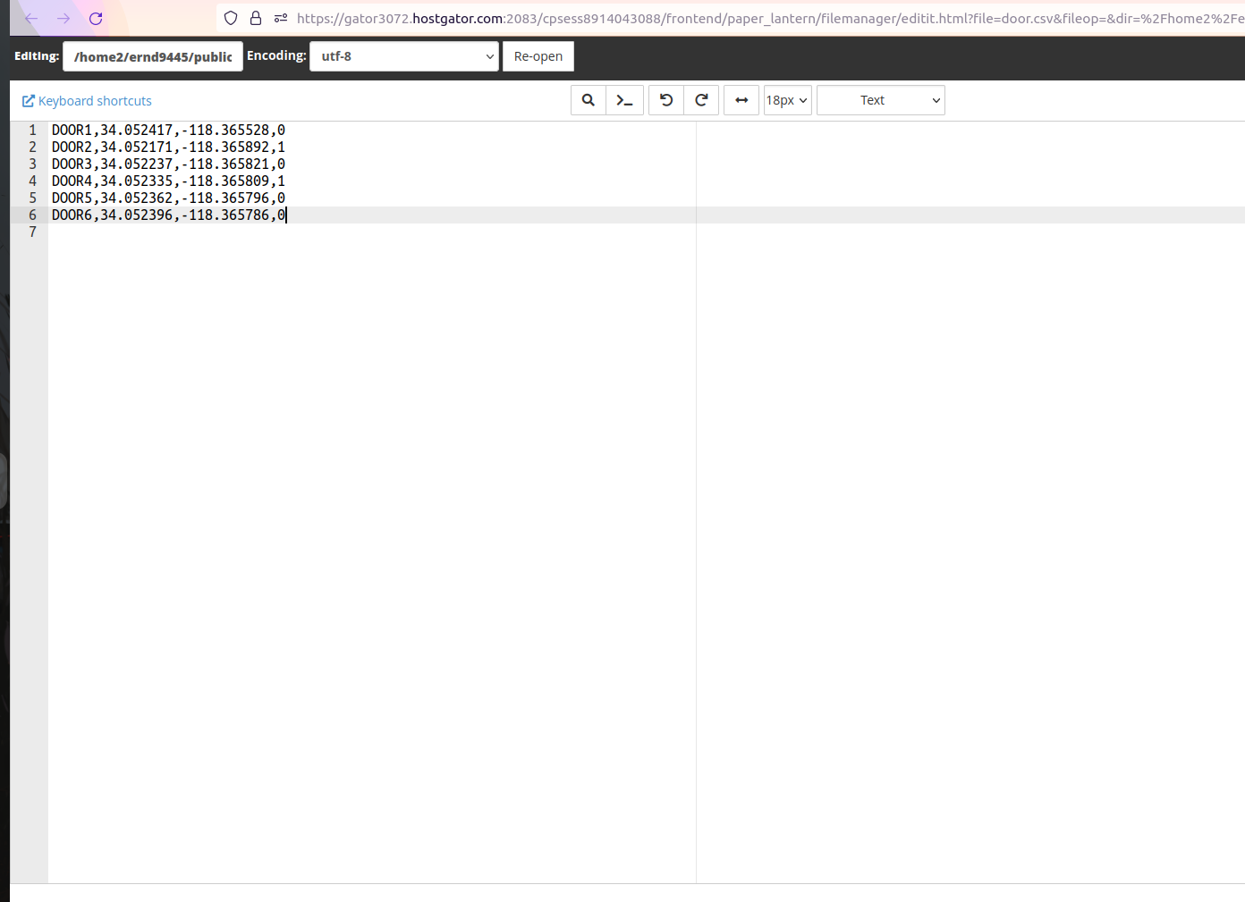

The Web Map will show mark according to the csv file if the status is 1 it will mark location on map if 0 then it will disappear from map.
Map Checks csv every 10 sec.
Esp updates csv every 30 sec.

